Phones and details

* 1. Apple iPhone 15 Pro Max
* About: The smartphone features an impressive 6.70-inch touchscreen display, offering a remarkable 120Hz refresh rate and a resolution of 1290×2796 pixels at an exceptional pixel density of 460 pixels per inch (ppi). The Apple iPhone 15 Pro Max is driven by the robust hexa-core Apple A17 Pro processor paired with 8GB of RAM, ensuring smooth performance. It also supports wireless charging, adding an extra convenience layer to its feature set.
* 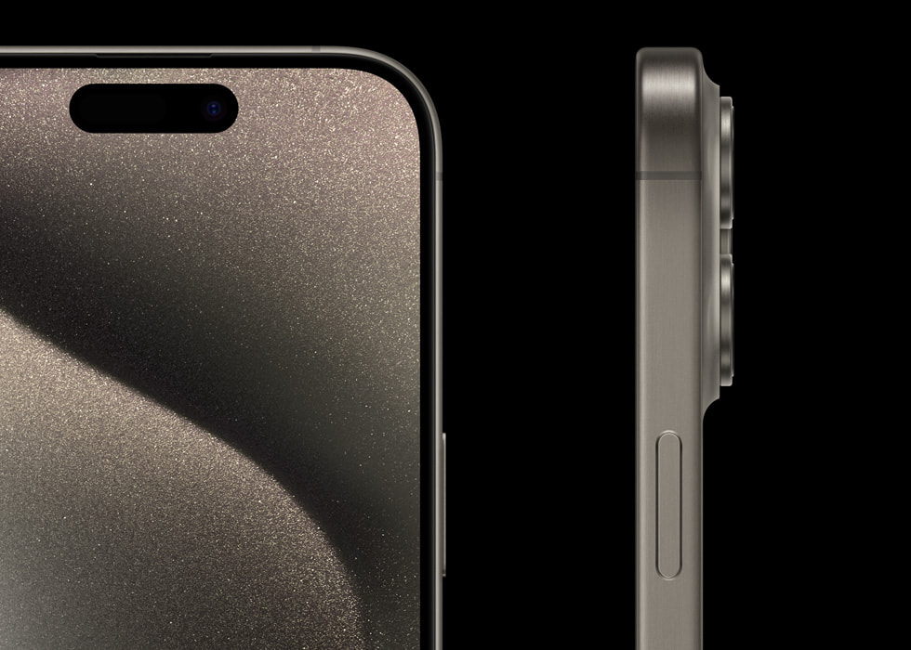
* 2. Apple iPhone 14 Pro Max

About: Everything was mind-boggling, from the stunning and massive 6.7-inch Super Retina XDR OLED 120Hz display to the A15 Bionic chipset on the Apple iPhone 13 Pro Max. However, Dynamic Island stood out the most this year, which finally replaced the old notch in the Apple iPhone series. This interactive pill design, with valuable functionalities through various app support, is an absolute beauty, to say the least!

* 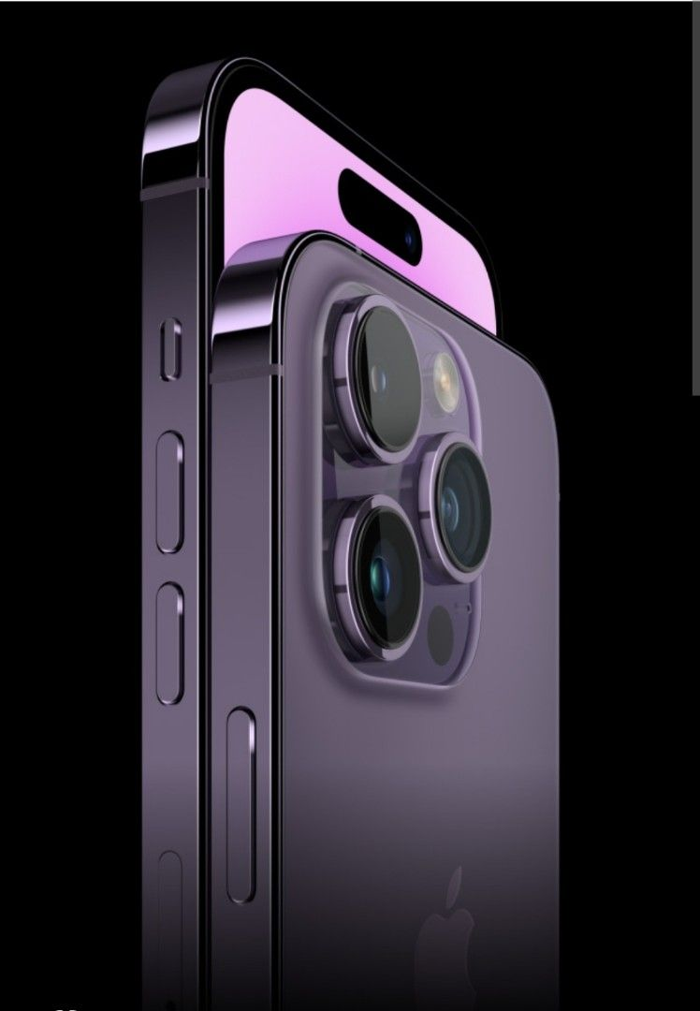
* 3. Samsung Galaxy S23 Ultra

About :  it is powered by the Qualcomm Snapdragon 8 Gen 2. Additionally, it offers at least 12GB RAM and 256GB of internal storage. So you can opt for up to a whopping 1TB of storage.

Then comes the display, which is just breathtaking, to say the least. The 6.8-inch Dynamic AMOLED 2X QHD+ display with a 120Hz refresh rate. In addition, the display features the Infinity-O Edge Screen design, which is a sight to behold.

Speaking of the camera setup, the astonishing 200-megapixel primary rear sensor is a showstopper. It’s complemented by two proficient 10-megapixel sensors and a 12-megapixel sensor. On the front, the 12-megapixel selfie camera excels at capturing fantastic selfies

* 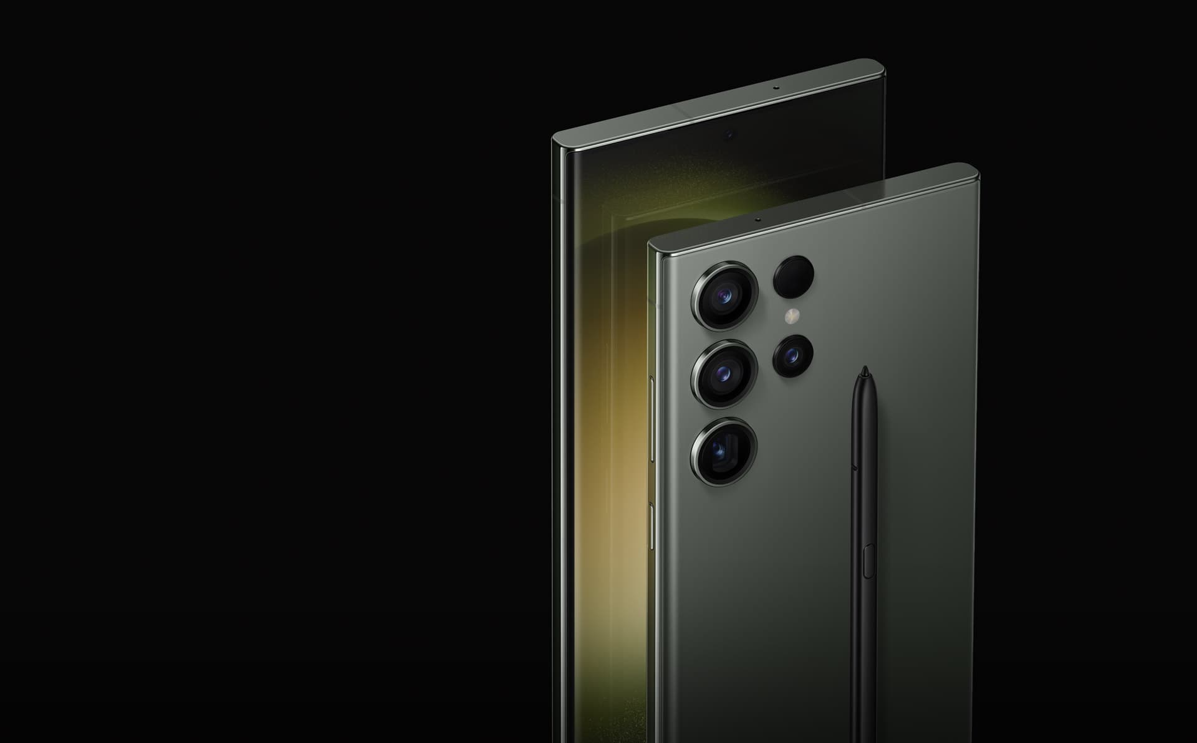
* 4. Vivo X90 Pro

About : The Vivo X90 Pro has an expansive 6.78-inch display, providing Full HD+ visuals with a crisp resolution of 1260 x 2800 pixels. Its substantial 4,870mAh battery capacity is truly remarkable, ensuring enduring power.

The Vivo X90 Pro doesn’t disappoint on the camera front, featuring a triple camera arrangement at the rear (50-megapixel + 50-megapixel + 12-megapixel) and a 32-megapixel front camera. Notably, this Vivo X90 Pro incorporates an Xtreme Night Video algorithm, enabling you to capture the vibrant essence of nightlife in all its glory.

* 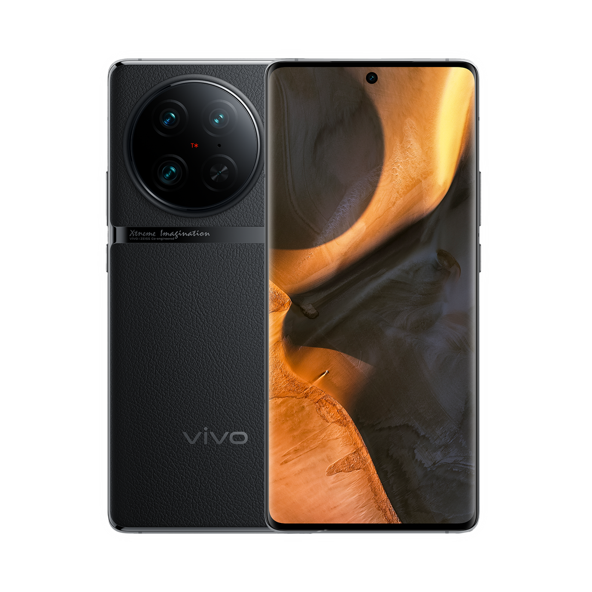
* 5. Samsung Galaxy Z Fold 5

About : Imagine a vibrant 7.6-inch foldable screen that’s a treat for your eyes! Not to mention, the front camera has received a significant upgrade, enhancing its performance. This phone has a triple camera setup, boasting 50-megapixel, 12-megapixel, and 12-megapixel lenses for stunning shots. Moreover, it excels in recording high-quality videos at various speeds. And let’s not overlook the dual front cameras – a 10-megapixel and a 4-megapixel lens – for selfies that truly stand out!